Neuron3D Documentation
By Frank Postma.

Some additions by Jaap van Pelt - 8 April 2009

Introduction.

Neuron3D exists as 2 tools:
- Neuron3D
- Neuron3D_Movie

Neuron3D is mainly used for looking at individual neurons in solid rendering.

Neuron3D_Movie is used for larger-scale networks and for creating POVRAY movies
of a series of neural networks, or just a movie in which the user moves about in a (single)
neural network. Movies can be made from multiple files which for example represent a
developmental process, for example 10 frames in which each frame represents a certain
time point in development.

In both programs, snapshots can be made and also snapshots using POVRAY can be
made from a single situation.

The program which makes the snapshots and frames of the movie is called POVRAY,
which is freely downloadable.
(At http://www.povray.org/ - download 32-bit (10 Mb) via the web – version 3.6.1c)

(java3D – download j3d-1_5_2-windows-i586.exe)

Neuron3D_Movie is capable of creating an .AVI movie from the outputted .BMP’s (the
pictures created b POVRAY are saved as .BMP’s)

Neuron3D walk through:

When the program is started, the following form appears:

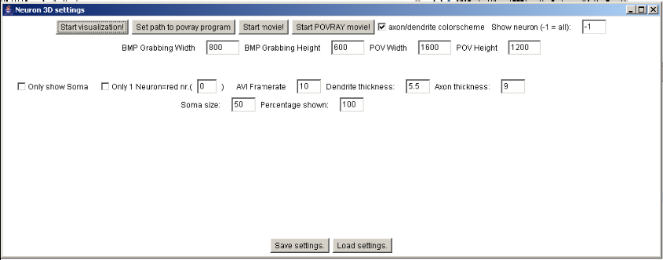

If you haven’t specified the path to the povray program (that is for example the location
of the pvengine.exe file that comes with povray) do it first.
If you want to look at one neuron at a time, type 0 into the textbox next to “Show
neuron”.
You can save all your settings by clicking Save settings. When you choose the default,
these setting will be loaded next time.
Then, when you want to start viewing your model, press Start visualization, and choose
the netmorph output file of your choice.
Remember that Neuron3D is not intended to view very large scale networks at once, but
rather to view a single neuron at a time of the (large scale) network.
The following screen, the rendering screen, appears:

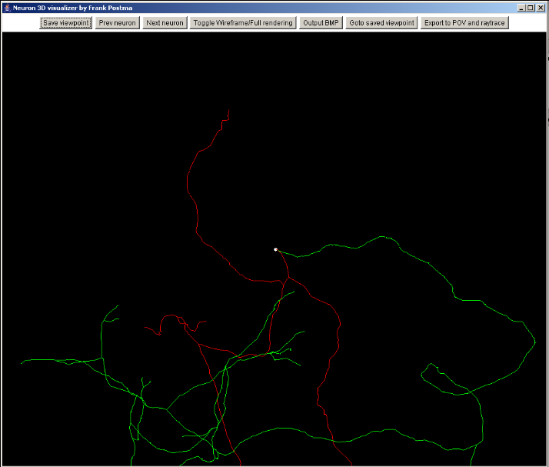

The axon is green, and red are the dendrites.
You can move through the model using the mouse;
Mouse movement when left mouse button pressed: rotation.
Mouse movement when right mouse button pressed: translation.
Mouse movement with ALT and left mouse button pressed : zooming in/out.
(in Linux, you can use the scroll-wheel on the mouse for zooming.)

When you press “Toggle Wireframe/Full rendering” the model is fully rendered, and you
can for example see the difference in neurite thickness between segments.
When you press Next neuron, the next neuron in the model is exclusively rendered, and
so on.
When you want to export to POV and raytrace, remember to first press the “Save
Viewpoint” button.

Neuron3D_Movie walk through:

When the program is started, the following form appears:

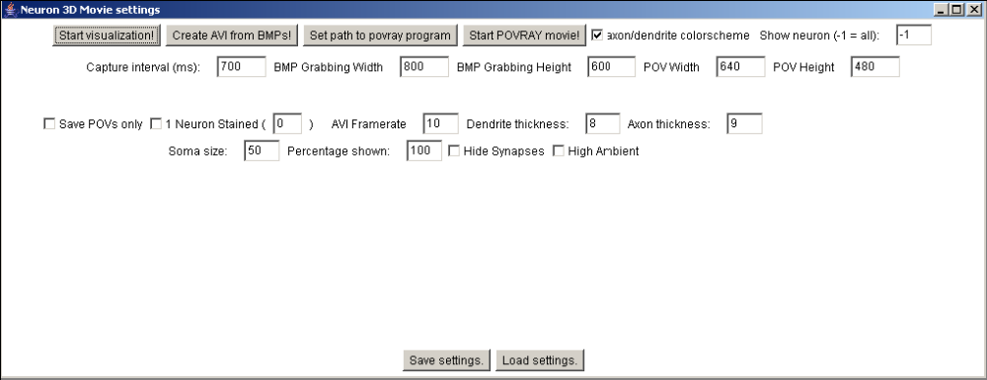

If you haven’t specified the path to the povray program (that is for example the location
of the pvengine.exe file that comes with povray) do it first.
If you want to look at one neuron at a time, type 0 into the textbox next to “Show
neuron”.
The “Capture interval (ms)” option is used when capturing the movie. Each frame is
“shot” at intervals specified by this option. So when you specify 50, the movie will be
taken at 20 Hz.
You can save all your settings by clicking “Save settings”. When you choose the default,
these setting will be loaded next time.
Then, when you want to start viewing your model, press “Start visualization”, and choose
the netmorph output file(s) of your choice.
The following screen, the rendering screen, appears:

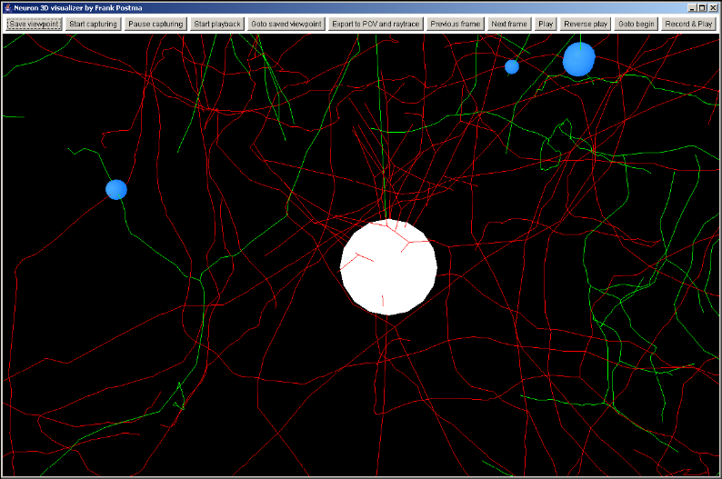

The creation of a movie of a developing network goes like this:
1) (You have choosen the files you want to include in the movie.)
2) Choose a good camera position and angle.
3) Press record & play. The button text now changes.
4) When the button “record & play” is back again, your movie has been captured.
5) Exit this screen (close it via the cross)
6) Press “Start povray movie”
7) When finished rendering all frames, choose a location to save the movie .AVI file.

The creation of a navigation-movie goes like this:
1) You have choosen the (large scale) network of your choice.
2) When you press “Start capturing”, your movements and navigation will be
recorded until you press “Stop capturing”.
3) You can review your movie-recordings by pressing “Start playback”
4) When ready, close this window.
5) There is an option called “save povs only”. When selected, the .pov frames are
created without rendering them. You can render these .pov files manually yourself
later with povray. And you can combine the rendered BMP’s using
Neuron3D_Movie. (“Create AVI from BMP’s!” button in the main screen)
6) Press “start povray movie”.

Also, a combination of both techniques is possible, so capturing the navigation while
playing through the development frames (using “Play” – this starts playing through the
development frames)
From the render screen, you can also press “Export to POV and raytrace” like before.

